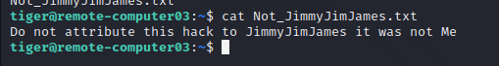

Final Project Lawfare Cyber Security Class
Final Report

Jim Byrne 02/06/2023

Project Goal: Write a bash script that triggers a system command

Dream Project: Install a virtual machine and Kali Linux on target network target Computer 1 then buid an attack G.U.I. on the infected Computer 1 and then targets Computer 2 with a power supply attack that reboots Compter 2.

Background: 20 days ago I had never programmed, I was struggling with some of the basics of using the network scanning tools and simple system commands.

My starting goals in the coarse were to get a peak into “hacking” to inform my artistic practice and improve my reading of technical writing.

My Final project was going to be a simple script that triggered a system command, probably a variation on “>shutdown now”
like somethings I found in a Linux book.

Change in what was practicle: 8 days ago I started using ChatGPT for help with python code.

6 days ago I listed to Lawfare editor-in-chief Benjamin Wittes’ interview with Eve Gaumond, an AI scholar at the Public Law Center of the University of Montréal
[ https://www.lawfareblog.com/lawfare-podcast-chatgpt-tells-all ]

In this podcast Benjamin works with Chatgpt to create a podcast about Chatgpt based on Eve’s research. Here I learned about how to structure my question to Chatgpt. Eve is very good at breaking down her goals into smaller chucks and chaining prompts together.

Very generally Eve Gaumond would ask a scene setting question, then she would trigger Chatgpt to modify that first answer, and then modify it again, until she got a working results.

As of 9pm on my 8th day of programming using Chatgpt
This is my results.

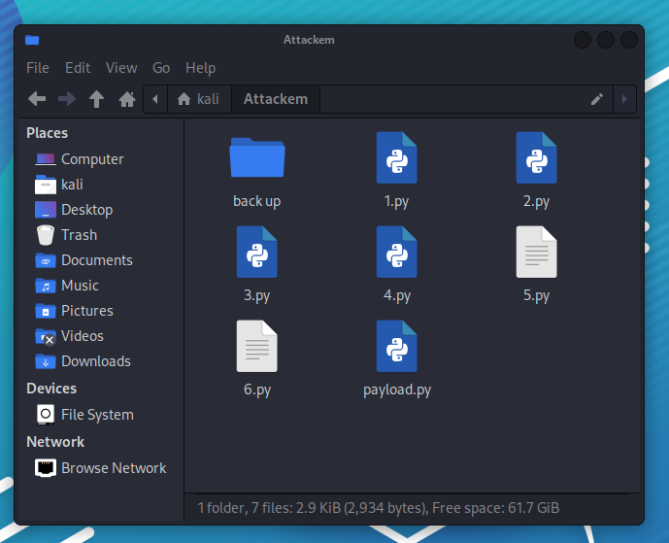
I made a directory in Kali Linux with 7 python files.

File “1.py” is a python file
in this file I have code that makes a graphical user interface (GUI)
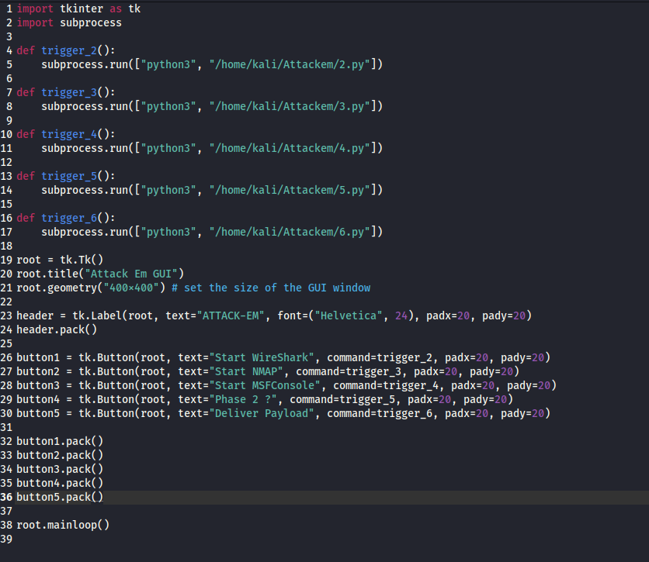

The “tkinter” import commands imports a python module for working with GUI’s, builds the buttons and points the buttons to other files that do work.

To make clear that rate I was able to progress,
15 Days ago I was using Google and trying to read python instruction web pages and videos.

All I could do was 2+2 and could not find an explanation of how run more than one command at a time and could not figure out “where python ran”.

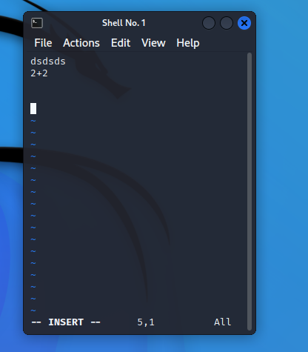



I created a desktop shortcut that triggers file “1.py”

using this code generated by Chatgpt

sudo nano /usr/local/bin/1.sh
#!/bin/bash
python3 /home/kali/Attackem/1.py
sudo chmod +x /usr/local/bin/1.sh
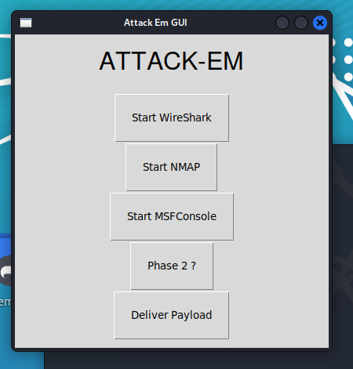
sudo nano ~/Desktop/1.desktop
[Desktop Entry]
Type=Application
Name=1
Exec=/usr/local/bin/1.sh
Terminal=true
My shortcut starts file 1.py
that creates this GUI window.

Using Eve’s modification strategy I asked Chat GPT
1. How to make a GUI
2. How to modify code to add buttons
3. How to get buttons to trigger an action
4. How are python programs organized
5. How to modify this code to improve formatting
of window and buttons
6. How to add a big text title

My GUI started like this, and gets modified to that and that
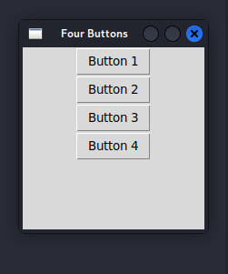
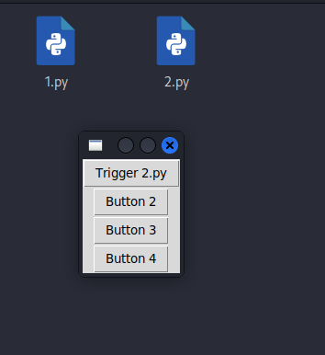
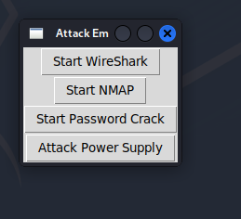

I tried to follow the Cyber Kill Chain and the syllabus of the class to organize my hack.

Student’s Note:
* Because the information was in a mix of video and text searching for details from the class is now Svery hard compared to using Chatgpt.

Button 1 uses this code to start the scanning software WireShark

import subprocess

def start_wireshark():
subprocess.run(["wireshark"])

def scan_wifi():
subprocess.run(["sudo", "iwlist", "wlan0", "scan"])

if __name__ == '__main__':
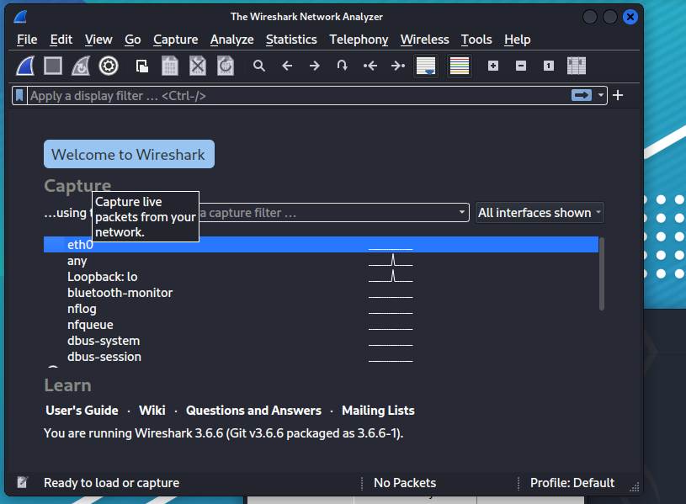
start_wireshark()
scan_wifi()

Here is some raw data from WireShark about my home network
a tool for using “grep” to search the output of Wireshark outputs.
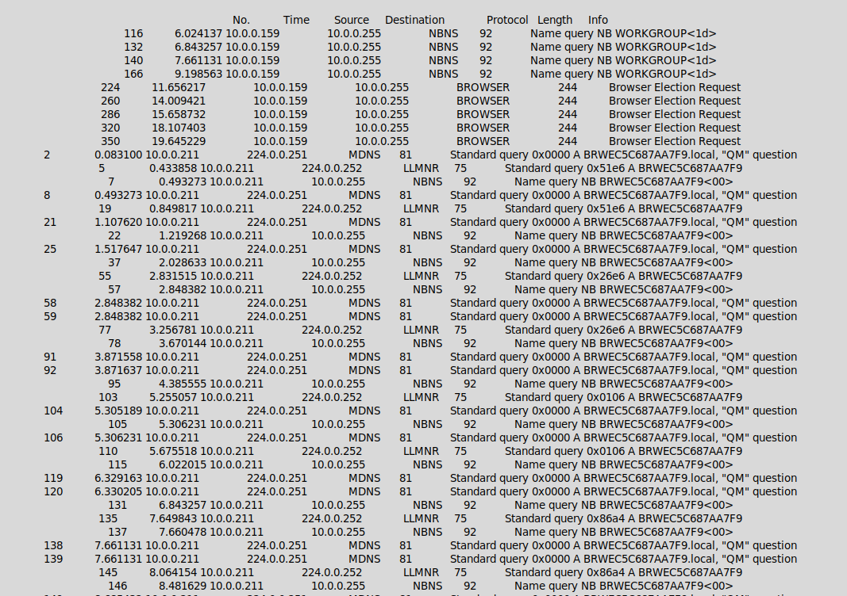



Data formatted with grep showing the ip address of Metasploitable which was pinging www.cnn.com

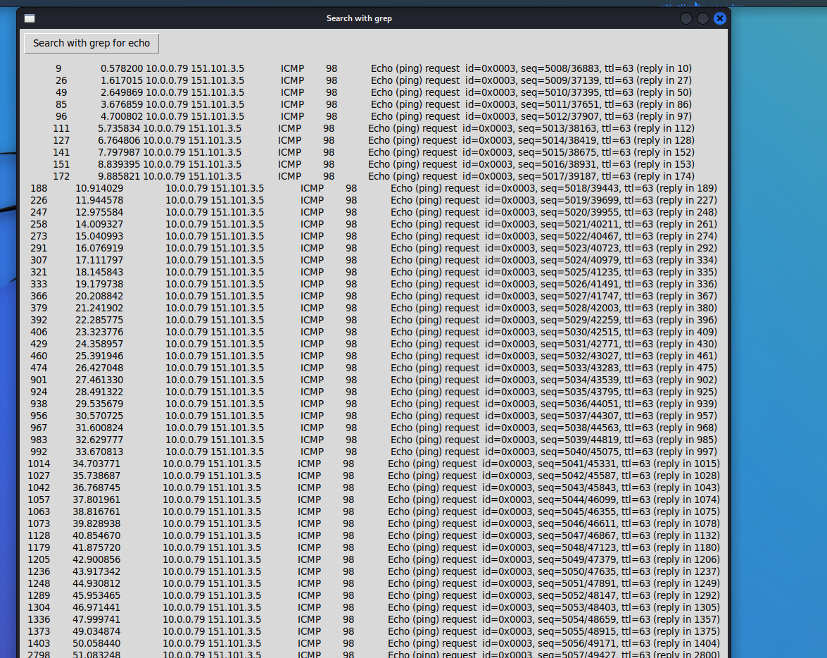

Code Generated by Chatgpt for using grep to find evidence of the a computer pinging.

import tkinter as tk
import subprocess
def search_with_grep_for_echo():
result = subprocess.run(['grep', '(ping)', '/home/kali/Attack_Folder/wire_shark_save.txt'], stdout=subprocess.PIPE)
result_text.config(text=result.stdout.decode('utf-8'))
root = tk.Tk()
root.title("Search with grep")
search_button = tk.Button(root, text="Search with grep for echo", command=search_with_grep_for_echo)
search_button.grid(row=0, column=0, padx=5, pady=5, sticky='w')
result_text = tk.Label(root, text="")
result_text.grid(row=1, column=0, padx=5, pady=5)
root.mainloop()

This code automates running NMAP if a ping is found.

def search_with_grep_for_echo():
result = subprocess.run(['grep', '(ping)', '/home/kali/Attack_Folder/wire_shark_save.txt'], stdout=subprocess.PIPE)
result_str = result.stdout.decode('utf-8')
result_text.config(text=result_str)
if "(ping)" in result_str:
run_nmap_window = tk.Toplevel(root)
run_nmap_window.title("Run NMAP")
run_nmap_button = tk.Button(run_nmap_window, text="Run NMAP")
run_nmap_button.pack()

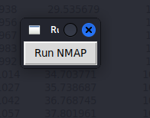

This is my work with Chatgpt on automating NMAP and dispaying results in side my GUI. By far my most usable port scan results of the semester.
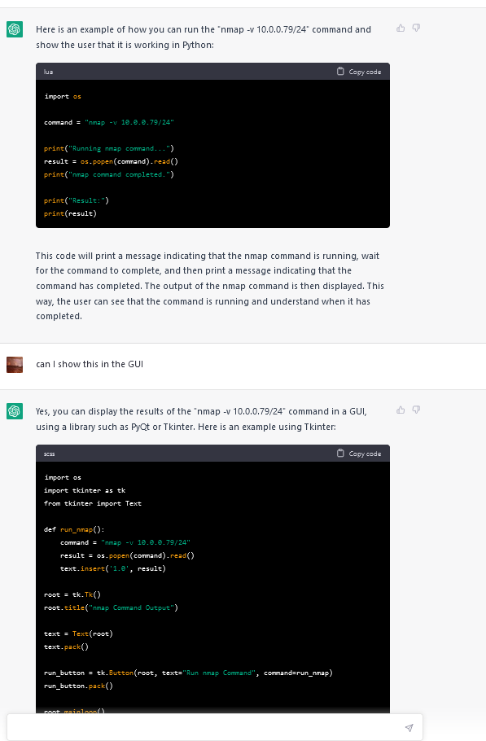

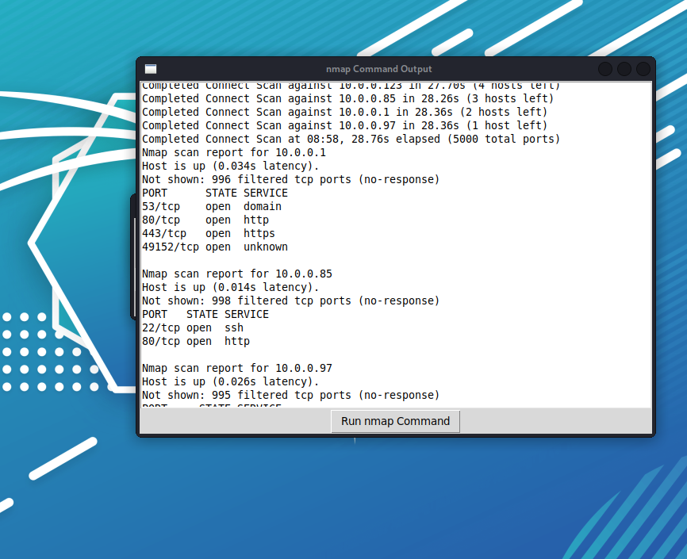

Working with Chatgpt to generate code for running MSFConsole
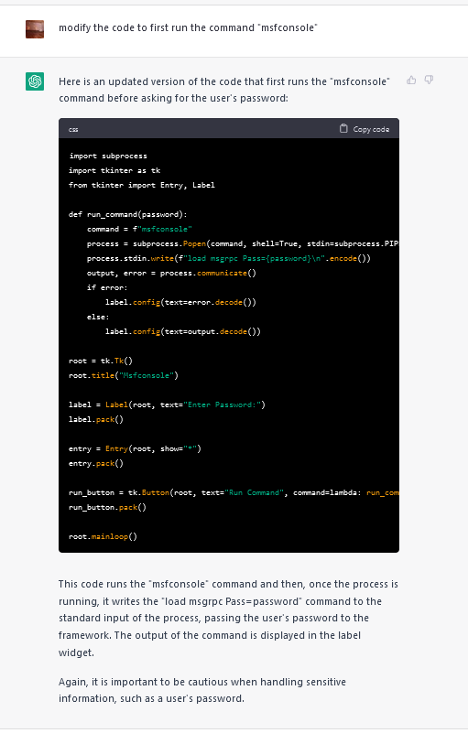

Because I care about security best practice my code does not store my users sudo password.

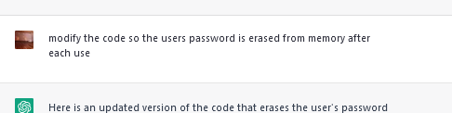

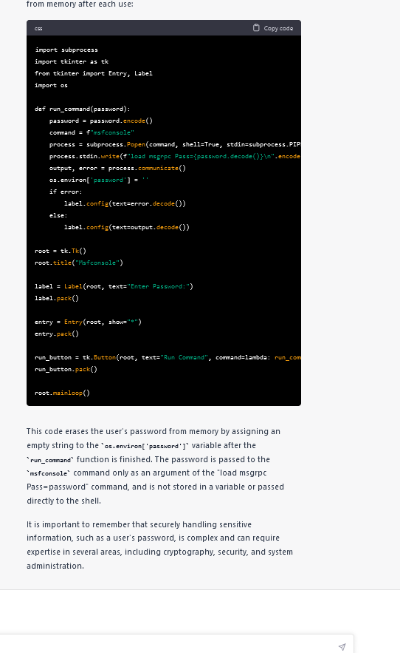

Screen shot of my GUI asking for Sudo password and transferring it to the system and MSFconsole running from my python code.
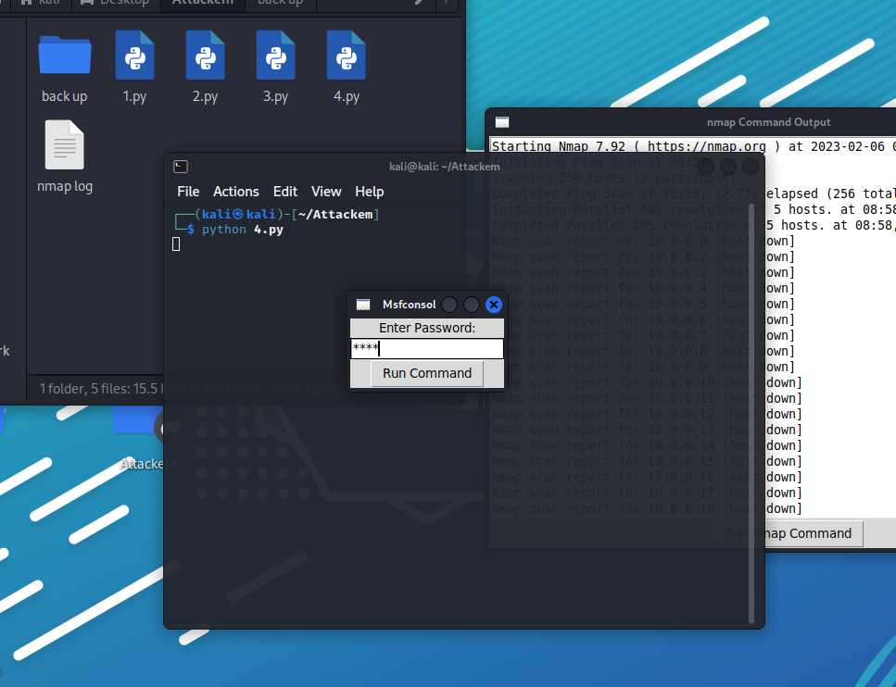
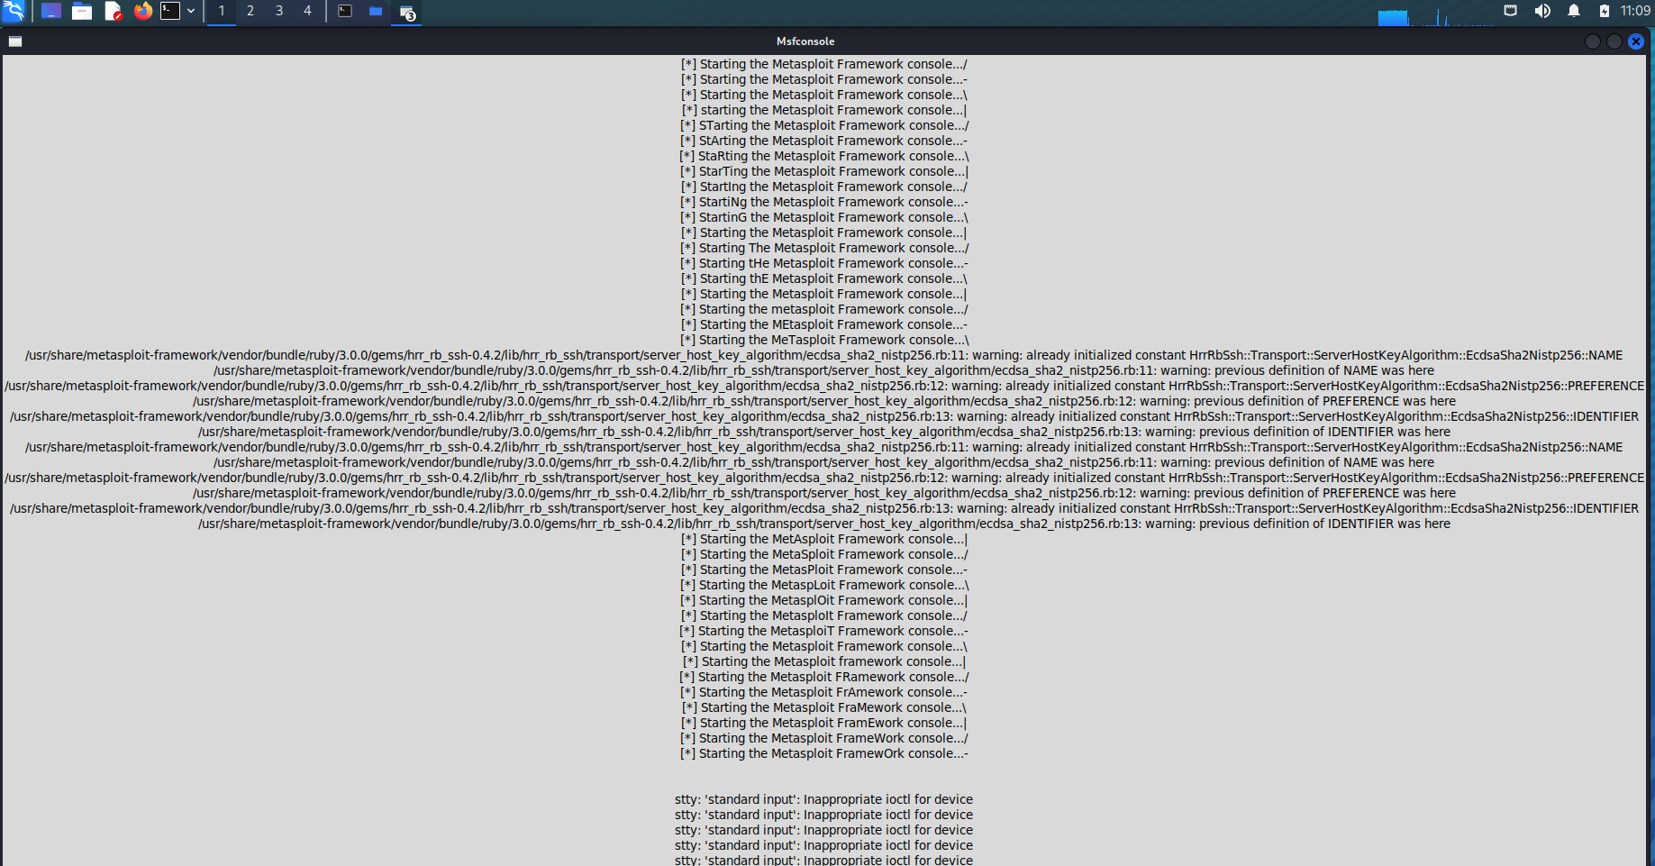

Chatgpt also proved to be very good at correcting bugs in my code.

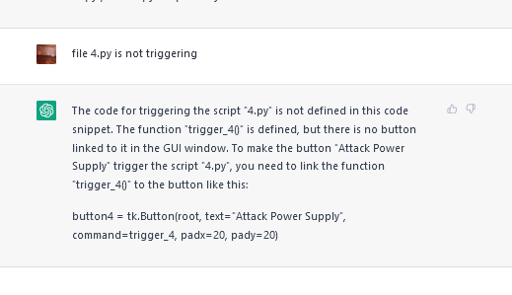
The forth button in my GUI is serving
as a placeholder for everything I failed to learn in the class.
This button triggers file 5.py

The code in “5.py” displays a random number that changes every .5 seconds and changes background color every 1 secod , has some text titles and has a link that goes to https://www.lawfareblog.com/support-lawfare

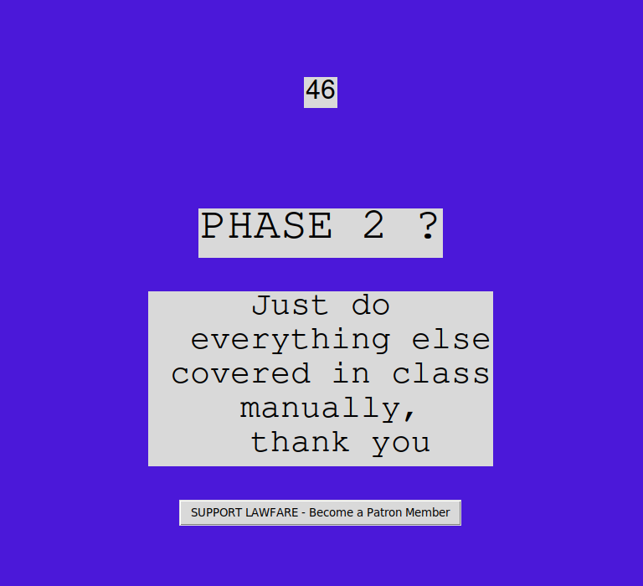
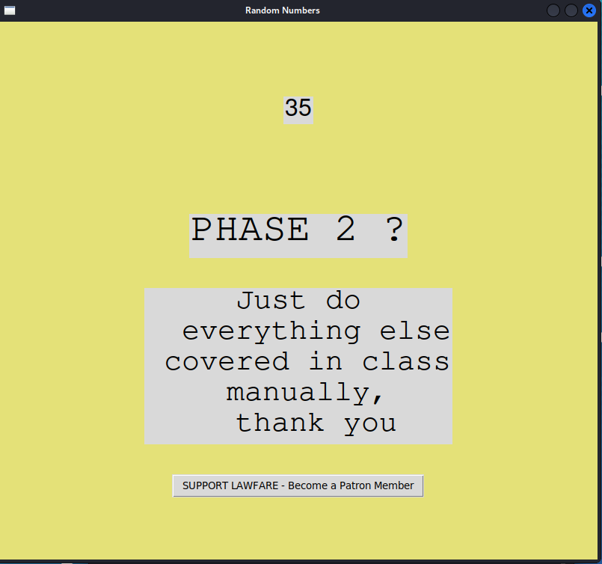


The last button attempts to transfer a file using ssh from Kali to Metaspolitable

Using this code

import paramiko

def transfer_file(filename, host, username, password):
ssh = paramiko.SSHClient()
ssh.set_missing_host_key_policy(paramiko.AutoAddPolicy())
ssh.connect(hostname=host, username=username, password=password)

sftp = ssh.open_sftp()
sftp.put(filename, '/home/msfadmin/payload.py')
sftp.close()
ssh.close()

filename = '/home/kali/Attackem/payload.py'
host = '10.0.0.79'
username = 'msfadmin'
password = 'msfadmin'

transfer_file(filename, host, username, password)

I saw some evidence that ssh was running, and received timeout error but was unable to transfer the file.
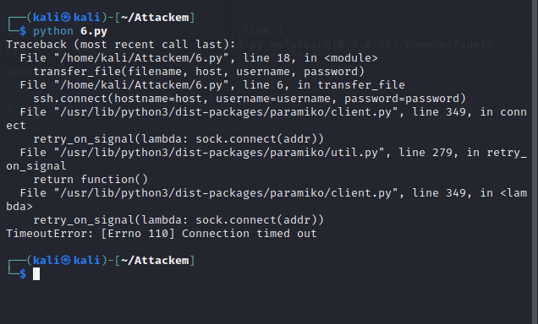

Some of my work in Chatgpt on transfer my payload.

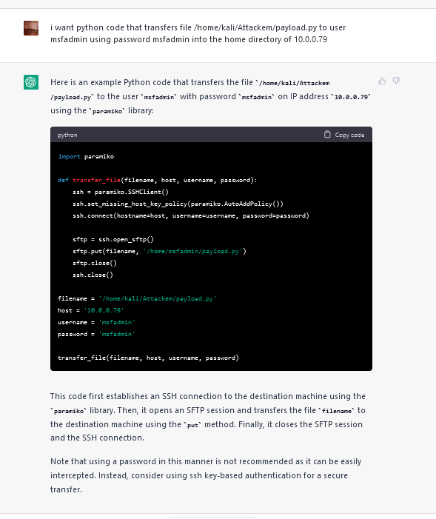

My payload file tries to get root access and then turn off the computer.
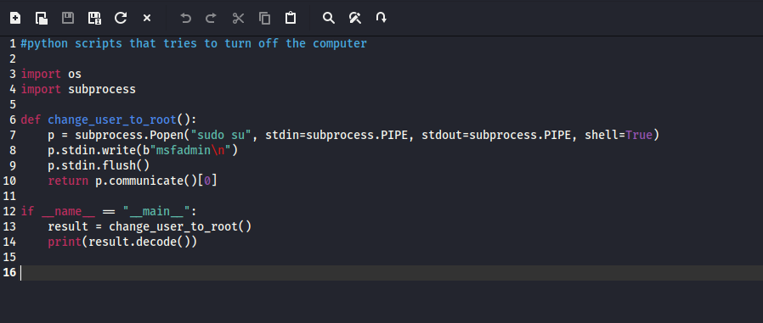

I used the “touch” command to create a file on the target machine and used Nano to enter the shutdown command.

My Chatgpt work, and using Nano in Metasploitable.

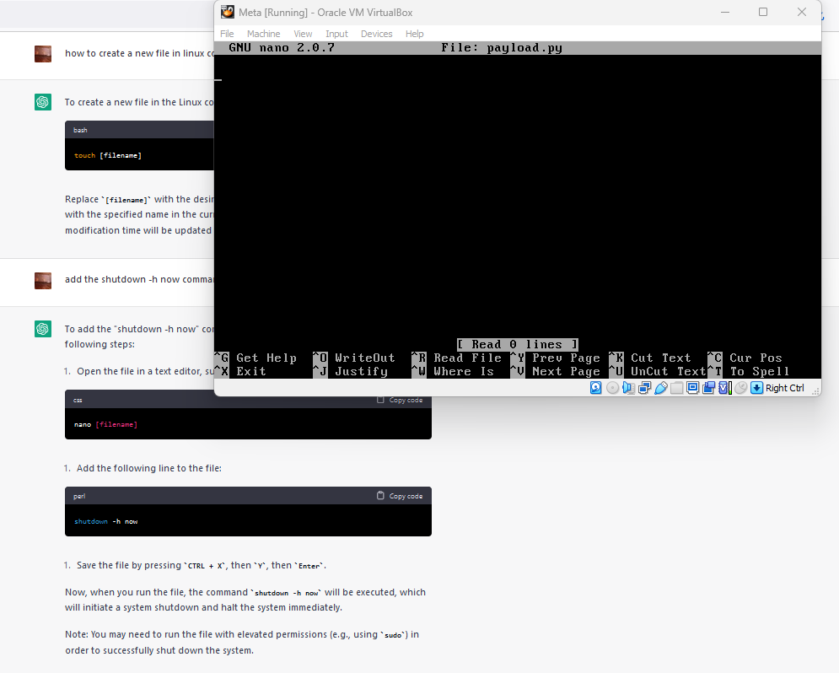

I triggered my payload and Metasploitable shutdown.
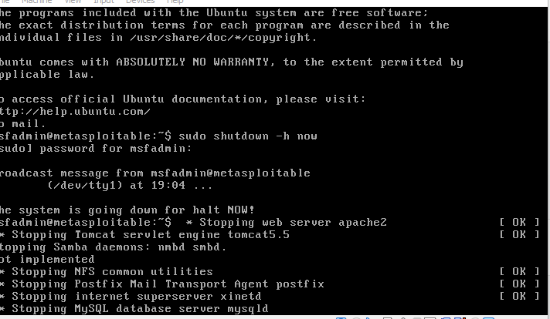

that was so much fun

